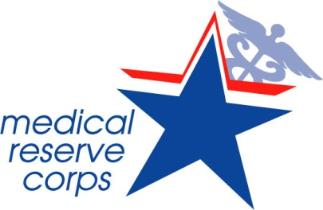

<INSERT MRC UNIT NAME>

PRESENTED TO

<First and Last Name>

In recognition of your outstanding contributions in support of the
Medical Reserve Corps Program during <insert event name>.
Your contributions have made a difference.

<Insert Name and Job Title>
Date
Volunteers Building Strong, Healthy, and Prepared Communities

