Accepting Volunteers into an Organization

When responders request to join an organization, they are added to a queue while they wait for an administrator to approve their membership. Follow the steps below to accept a responder into an organization.

- Click the Organizations tab, then set the Display Filter to “Organizations: I Manage”.

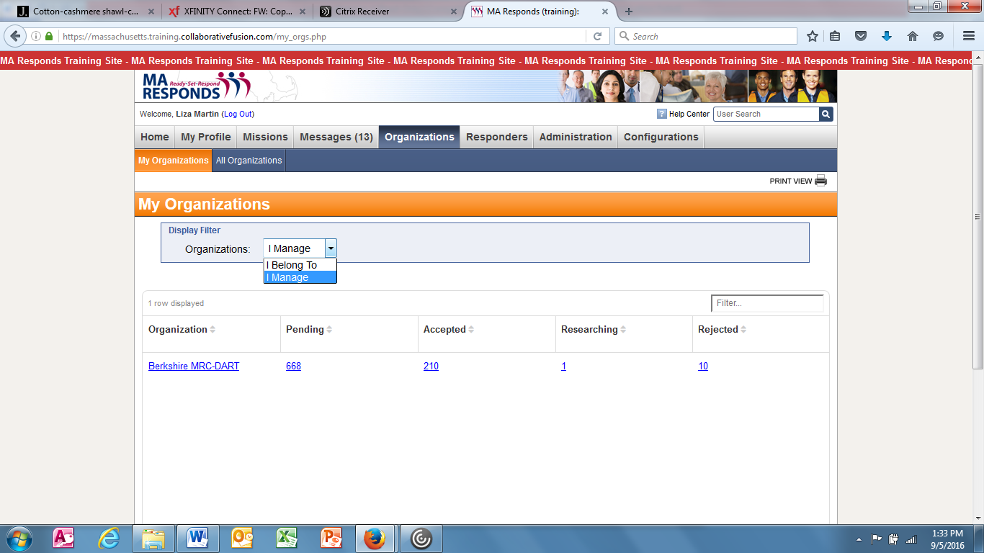
My Organizations Screen

- Click on the organization link to bring up the organization’s dashboard.

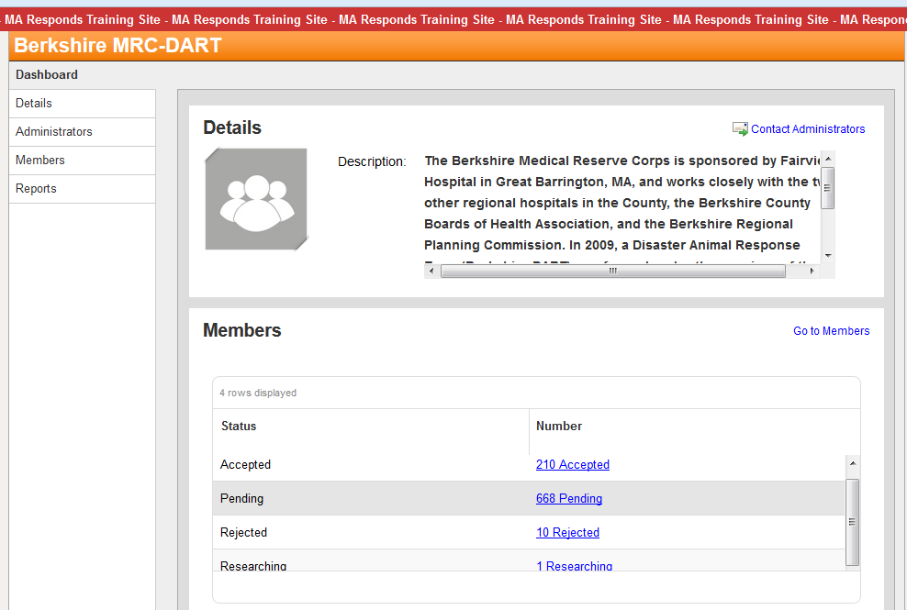
Organization Dashboard Screen

- Click on the “Pending” link to bring up a list of members pending acceptance to the organization.

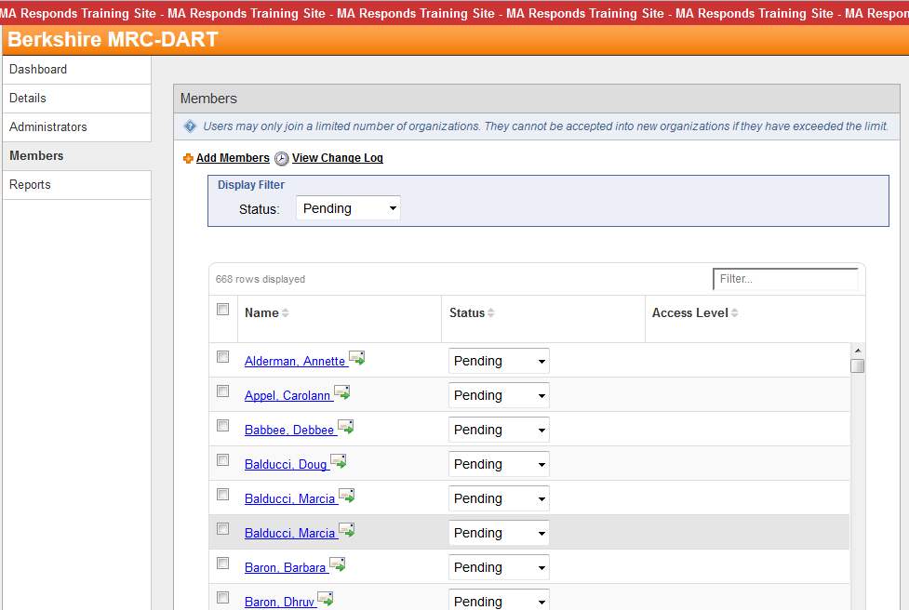
Organization Pending Members Screen

- Choose the members to accept by clicking on the checkbox(es) next to the name(s).

- Use the “Select an Action” dropdown menu to “Set to Accepted” and then click on the “Submit Action” button OR change the responder status to “Accepted” on the dropdown menu on the right hand side of the page.

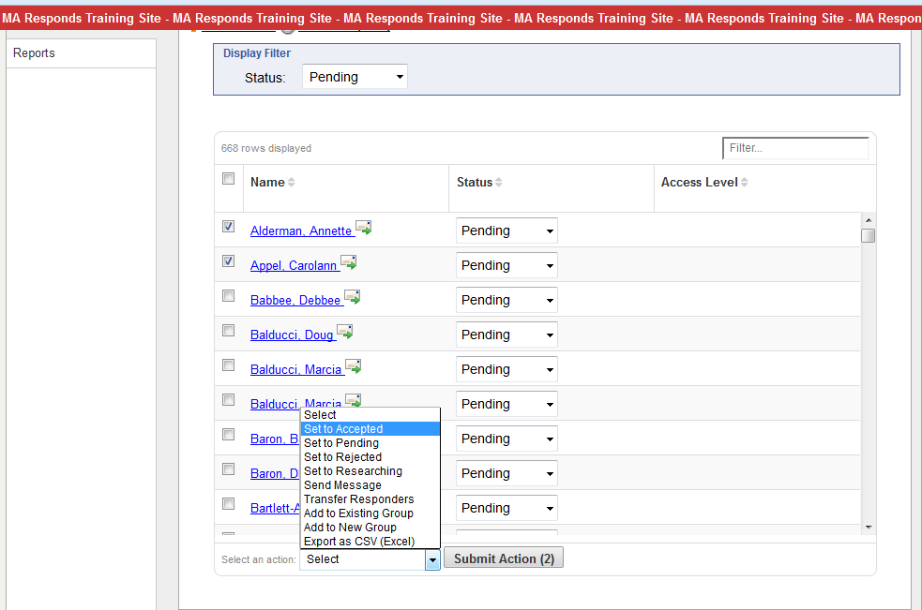
Organization Pending Members Screen
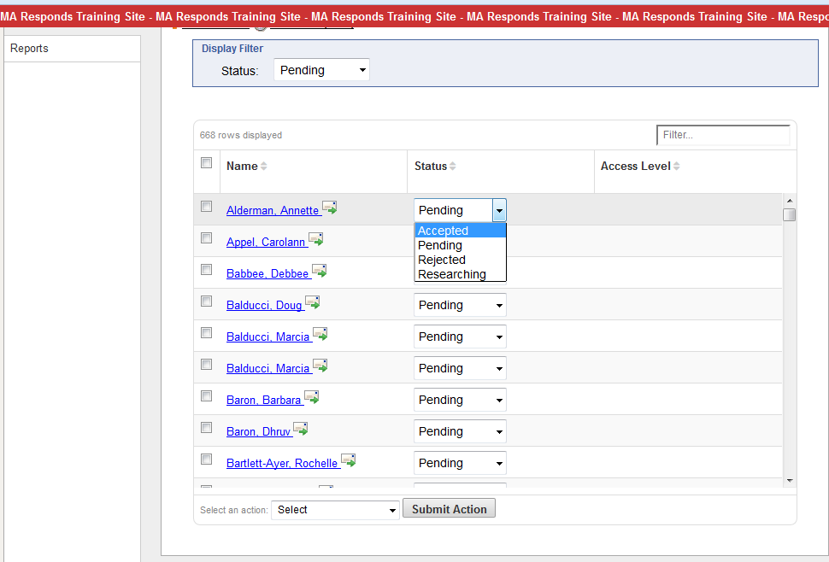
Organization Pending Members Screen

- Selected members who meet the qualifications for acceptance (completed background checks) will be accepted to the organization and will now appear in the “Accepted” filter in Members.

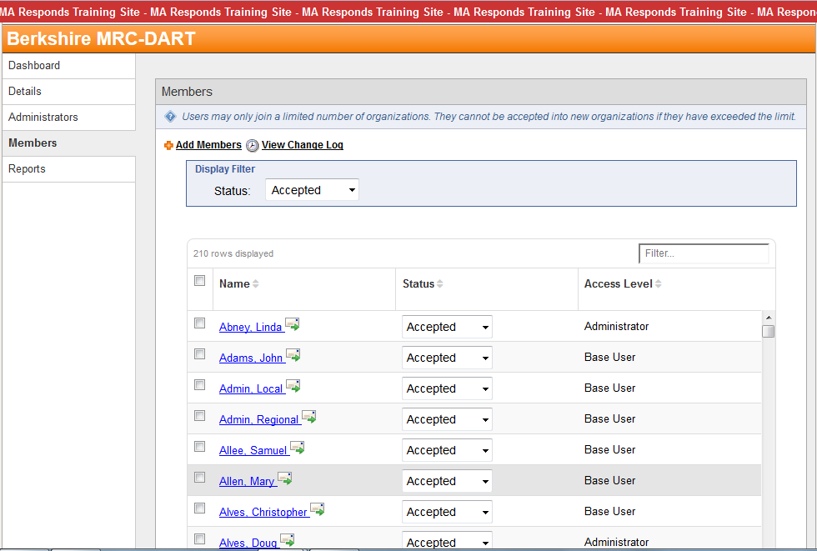
Organization Accepted Members Screen

- An administrator can also search for an individual responder to accept by using the Responder Search feature. Click on the “Responders” tab to bring up the “Responder Search” screen.

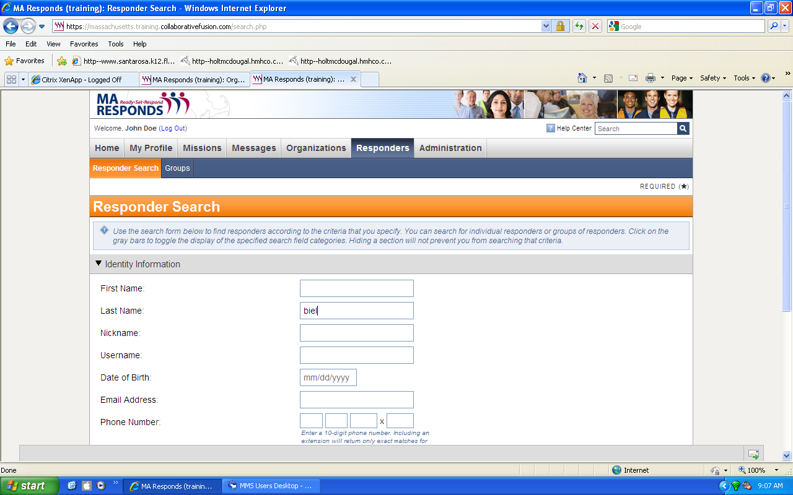
Responder Search Screen

- Type in the name of the responder to search for.

- Choose “Pending” volunteers in the “Memberships” selection criteria area.

- Click the “Search” button at the bottom right.

- Click on the link to the responder’s profile on the results screen.

- Set the responder’s status to “Accepted”.

